# Lab: Version Control Systems

Table of contents:

1. Create a GitHub Developer Profile
2. Create a GitHub Repository and test text file
3. Clone a Repository Twice
   1. Using **TortoiseGit**
   2. Using **GitBash**
4. Make Conflict
5. Upload changes from TortoiseGit clone
6. Try to update with GitBash
7. Resolving merging conflict
8. Make additional changes in TortoiseGit test file and update
9. My user name is ***HristoSpasov.***  You can follow the link in the header.
10. Here is my first repository

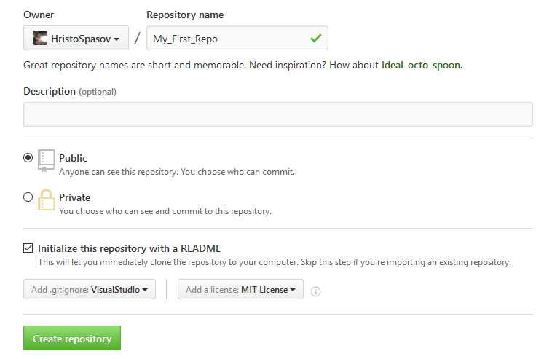

Created new file **HTS_test**

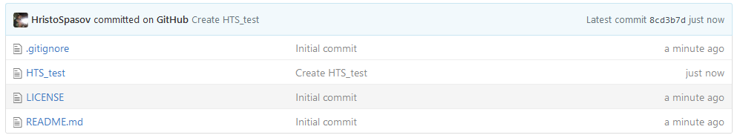

1. Cloning Repository Twice
   1. **TortoiseGit**

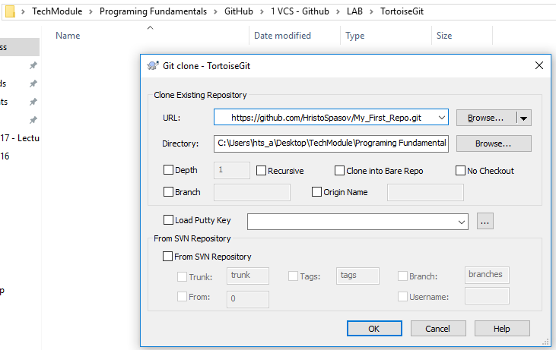

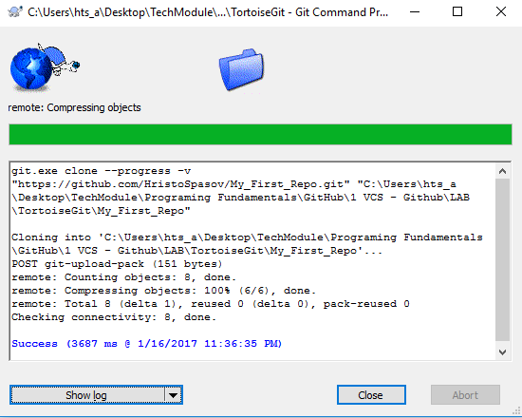

* 1. **GitBash**

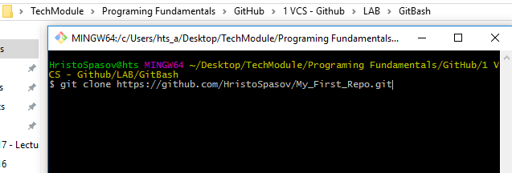

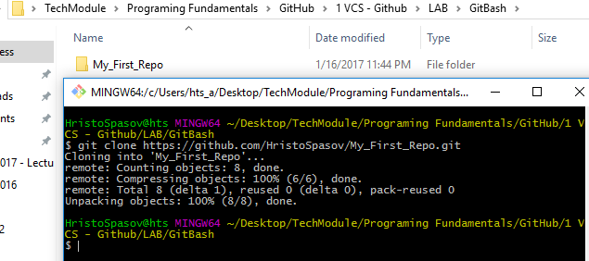

1. Make Conflict

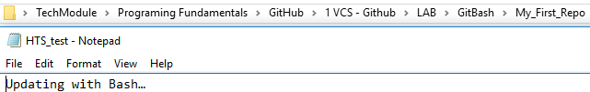

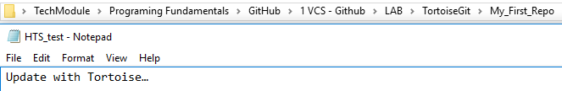

1. Upload changes from TortoiseGit clone

5.1 Before Commit

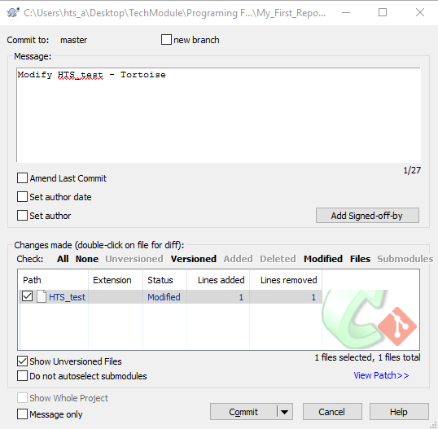

5.2 After Commit

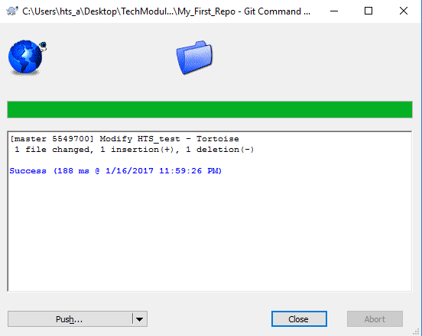

5.3 Push to GitHub

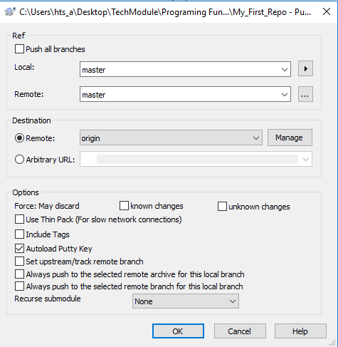

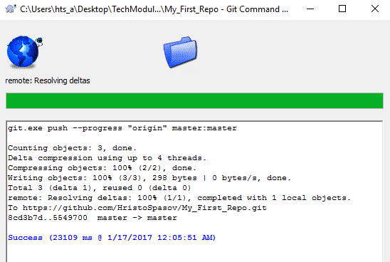

* 1. Result



1. Try to update with GitBash

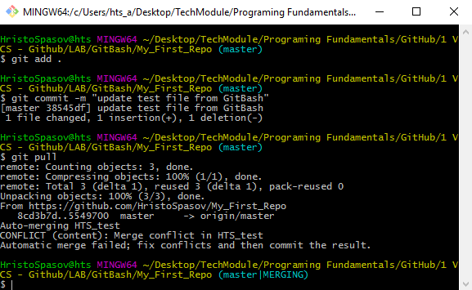

1. Resolving merging conflict

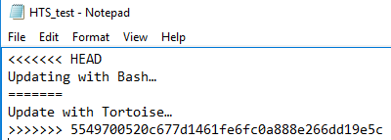

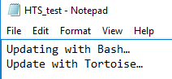

Push files to GitHub Repositority

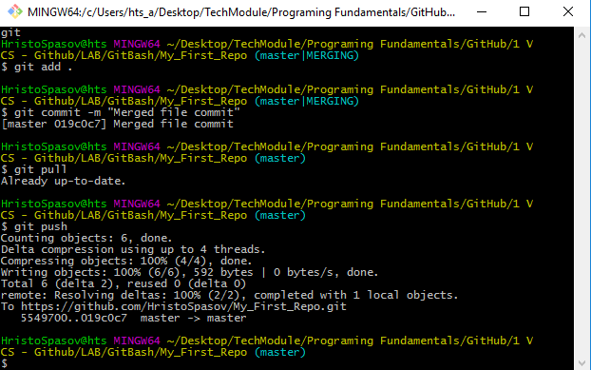

1. Make additional changes in **TortoiseGit** test file and update

Change test file

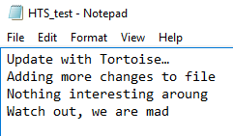

Commit change

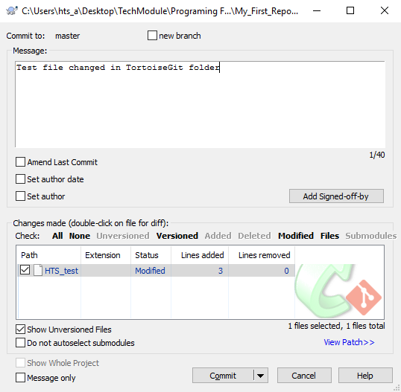

Commit report

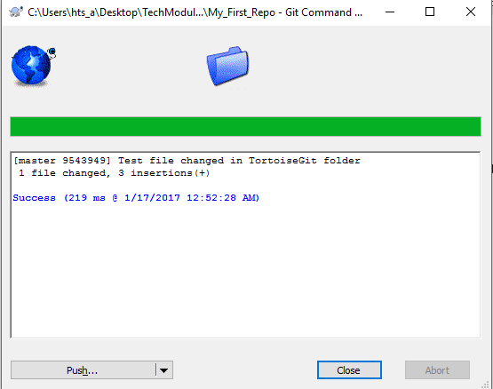

Push fail report

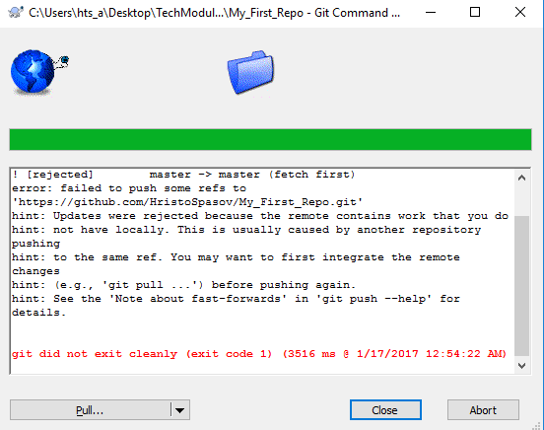

Pull report shows the files have been merged

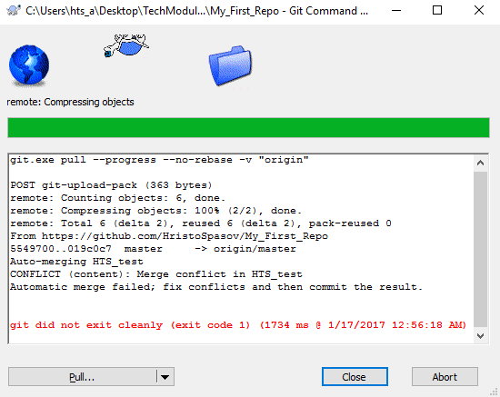

Resolving file and update file in GitHub

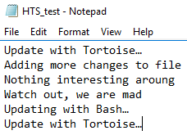

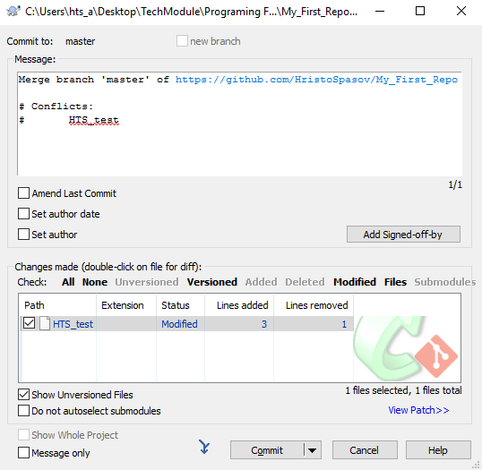

Commit report

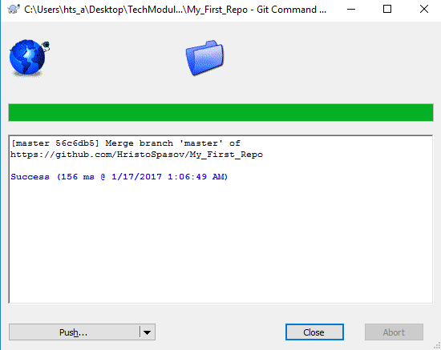

Push report – file successfully updated

